Eccentricity

Definition
# Source: AI Source: Provided by: [Data Path: Persons Table -> ID Column: 1, Name_En Column: Motasem Essam] -> From: [ChatGPT] on [7/25/2026]
Eccentricity is a numerical measure that describes the shape of a conic section by indicating how much the curve differs from a circle.
It is defined as the ratio of the distance from any point on the conic to its focus to the perpendicular distance from that point to its directrix.
$$\boxed{e=\frac{\text{Distance from point to focus}}{\text{Distance from point to directrix}}}$$
where $e$is the eccentricity.
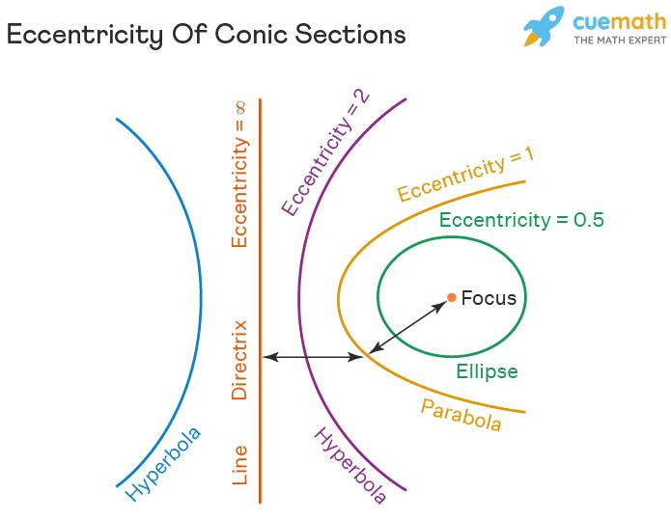
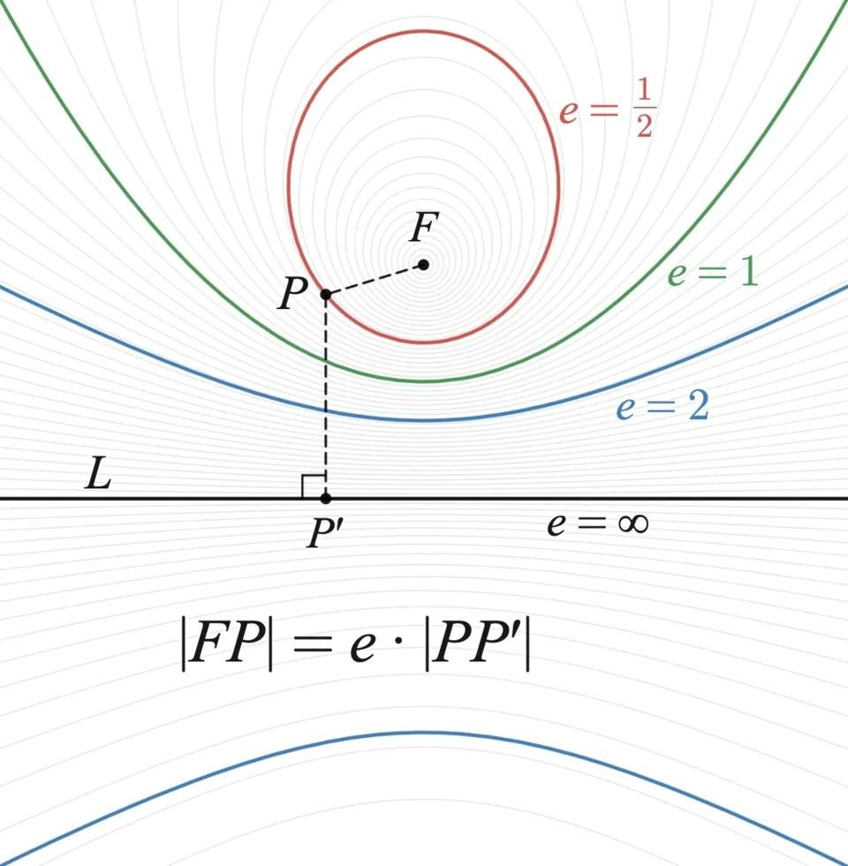
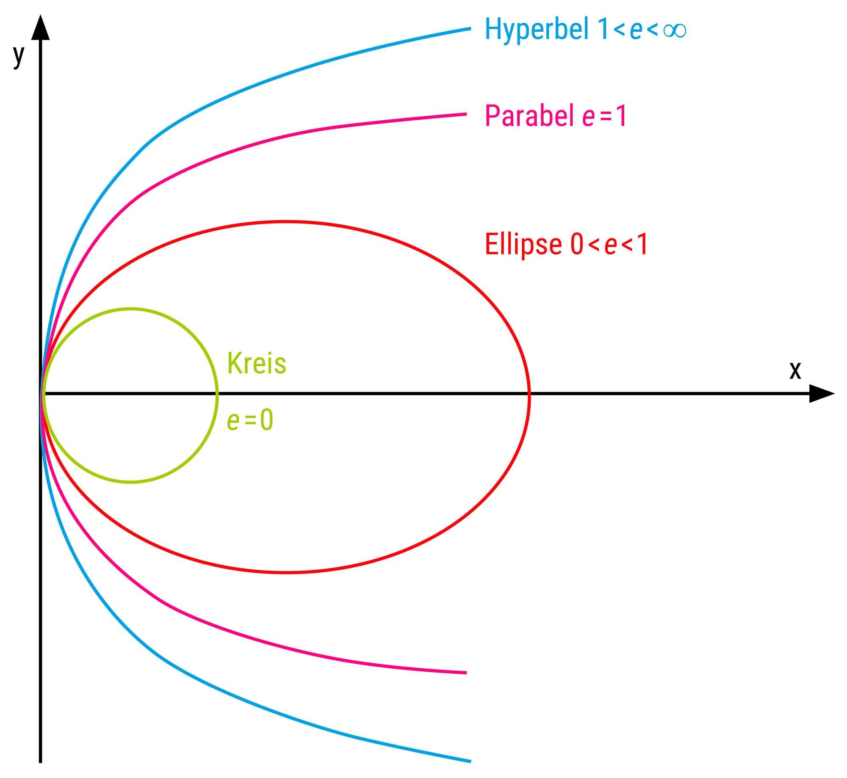
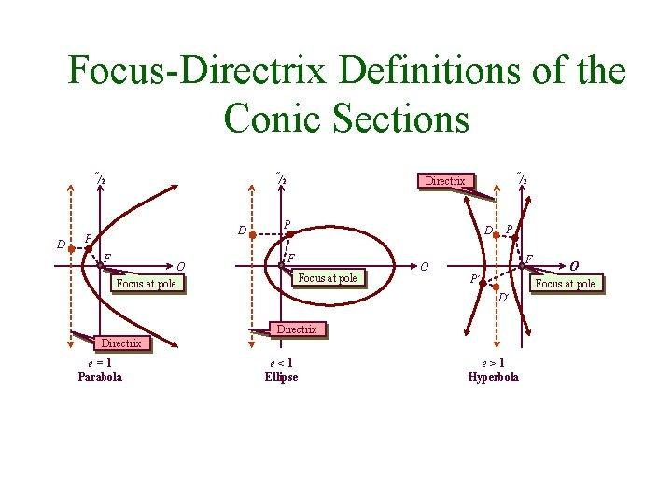
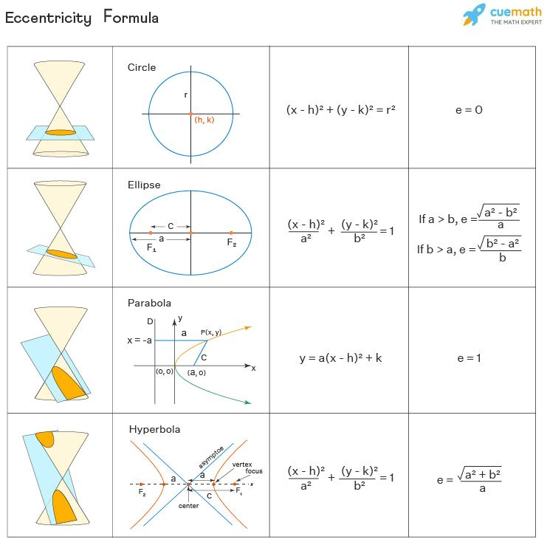

Eccentricity of Conic Sections
# Source: AI Source: Provided by: [Data Path: Persons Table -> ID Column: 1, Name_En Column: Motasem Essam] -> From: [ChatGPT] on [7/25/2026]
Eccentricity provides a unified way to distinguish the four main non-degenerate conic sections:
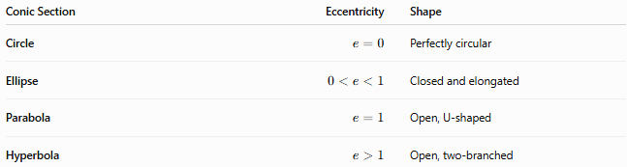
Conic Section | Eccentricity | Shape
Circle | $$e=0$$ | Perfectly circular
Ellipse | $$0<e<1$$ | Closed and elongated
Parabola | $$e=1$$ | Open, U-shaped
Hyperbola | $$e>1$$ | Open, two-branched
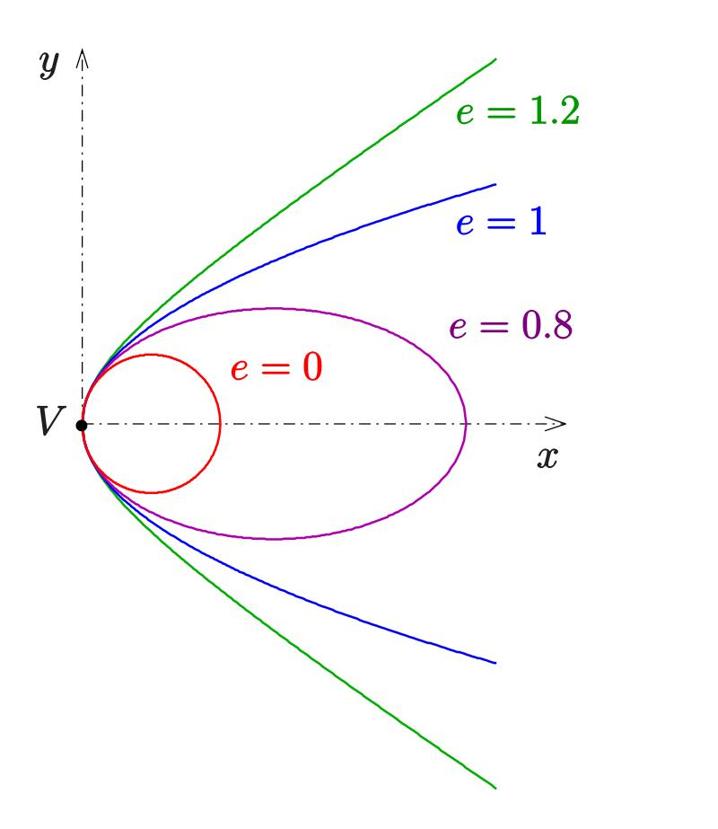
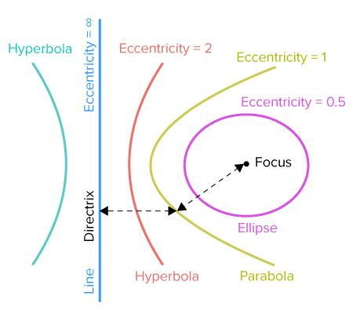
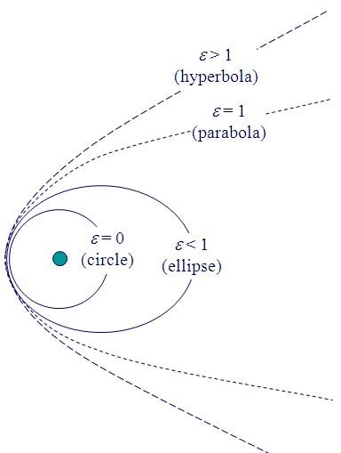
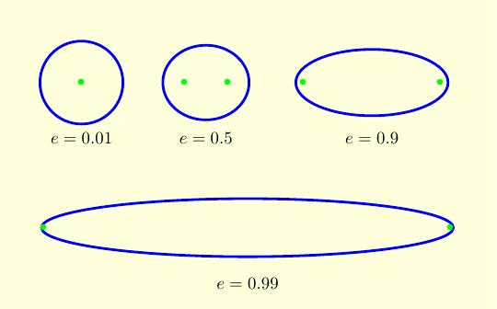

Classification
# Source: AI Source: Provided by: [Data Path: Persons Table -> ID Column: 1, Name_En Column: Motasem Essam] -> From: [ChatGPT] on [7/25/2026]
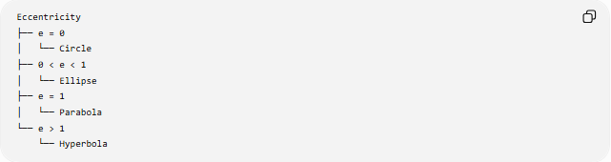
Eccentricity
├── e = 0
│ └── Circle
├── 0 < e < 1
│ └── Ellipse
├── e = 1
│ └── Parabola
└── e > 1
└── Hyperbola
Geometric Meaning
The value of $e$describes the relationship between the focus distance and directrix distance.
Circle — $e=0$
A circle is the limiting case of an ellipse with zero eccentricity.
$$\boxed{e=0}$$
The standard focus-directrix definition is treated as a limiting/symmetric case because a circle's two foci coincide at its center.
Ellipse — $0<e<1$
An ellipse has an eccentricity between 0 and 1.
$$\boxed{0<e<1}$$
- $e$close to 0 → ellipse is close to a circle.
- $e$closer to 1 → ellipse becomes more elongated.
For an ellipse:
$$\boxed{e=\frac{c}{a}}$$
where:
- $a$= semi-major axis
- $c$= distance from the center to either focus.
Also,
$$\boxed{c^{2}=a^{2}-b^{2}}$$
so
$$\boxed{e=\sqrt{1-\frac{b^{2}}{a^{2}}}}$$
Parabola — $e=1$
For a parabola, the distance to the focus always equals the distance to the directrix.
$$\boxed{e=1}$$
Thus:
$$\text{Focus distance}=\text{Directrix distance}$$
Hyperbola — $e>1$
A hyperbola has eccentricity greater than 1.
$$\boxed{e>1}$$
For a hyperbola:
$$\boxed{e=\frac{c}{a}}$$
where $c$is the center-to-focus distance and $a$is the semi-transverse axis.
Also,
$$\boxed{c^{2}=a^{2}+b^{2}}$$
therefore,
$$\boxed{e=\sqrt{1+\frac{b^{2}}{a^{2}}}}$$

Examples

Example 1: Circle
# Source: AI Source: Provided by: [Data Path: Persons Table -> ID Column: 1, Name_En Column: Motasem Essam] -> From: [ChatGPT] on [7/25/2026]
If the conic has eccentricity
$$e=0$$
then it is a circle.

Example 2: Ellipse
# Source: AI Source: Provided by: [Data Path: Persons Table -> ID Column: 1, Name_En Column: Motasem Essam] -> From: [ChatGPT] on [7/25/2026]
If
$$e=0.6$$
then
$$0<0.6<1$$
so the conic is an ellipse.

Example 3: Parabola
# Source: AI Source: Provided by: [Data Path: Persons Table -> ID Column: 1, Name_En Column: Motasem Essam] -> From: [ChatGPT] on [7/25/2026]
If
$$e=1$$
the conic is a parabola.

Example 4: Hyperbola
# Source: AI Source: Provided by: [Data Path: Persons Table -> ID Column: 1, Name_En Column: Motasem Essam] -> From: [ChatGPT] on [7/25/2026]
If
$$e=2$$
then
$$2>1$$
so the conic is a hyperbola.

Eccentricity and Shape
# Source: AI Source: Provided by: [Data Path: Persons Table -> ID Column: 1, Name_En Column: Motasem Essam] -> From: [ChatGPT] on [7/25/2026]
For ellipses, increasing eccentricity makes the ellipse more elongated.
$$e→0 ⇒ \text{more circular} \\ e→1 ⇒ \text{more elongated}$$
For hyperbolas, eccentricity also determines their geometric shape and relationship to their asymptotes.
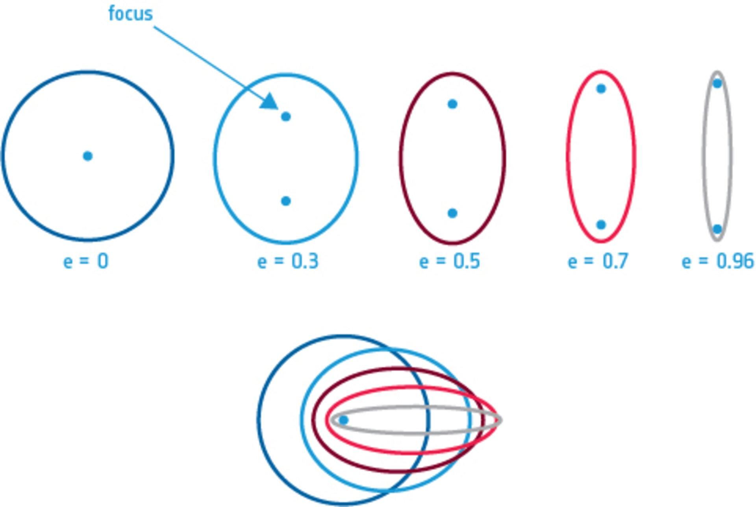
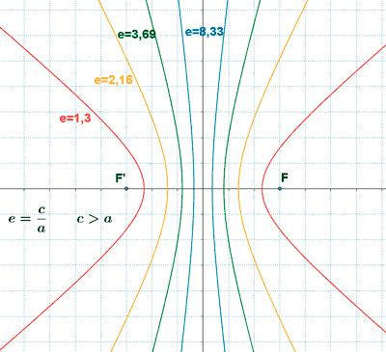
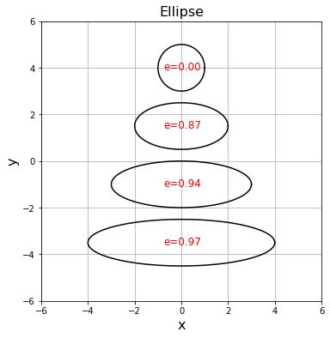

Relationship with Conic Sections
# Source: AI Source: Provided by: [Data Path: Persons Table -> ID Column: 1, Name_En Column: Motasem Essam] -> From: [ChatGPT] on [7/25/2026]
Eccentricity is one of the main classification properties of conic sections:
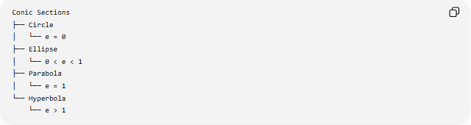
Conic Sections
├── Circle
│ └── e = 0
├── Ellipse
│ └── 0 < e < 1
├── Parabola
│ └── e = 1
└── Hyperbola
└── e > 1

Key Points
# Source: AI Source: Provided by: [Data Path: Persons Table -> ID Column: 1, Name_En Column: Motasem Essam] -> From: [ChatGPT] on [7/25/2026]
- Eccentricity is represented by $e$.
- It is a dimensionless quantity.
- It describes the shape of a conic.
- Circle: $e=0$.
- Ellipse: $0<e<1$.
- Parabola: $e=1$.
- Hyperbola: $e>1$.
- The focus-directrix definition provides a unified description of conic sections.

Conclusion
# Source: AI Source: Provided by: [Data Path: Persons Table -> ID Column: 1, Name_En Column: Motasem Essam] -> From: [ChatGPT] on [7/25/2026]
Eccentricity is the parameter that distinguishes the major types of conic sections according to their geometric shape. The critical values are:
$$\boxed{e=0:\text{ Circle}, 0<e<1:\text{ Ellipse}, e=1:\text{ Parabola}, e>1:\text{ Hyperbola}}$$

